EYE OF THE NEEDLE: A COMMUNICATION TOOL
BY
NANCY OELKLAUS

How often have you left a conversation feeling dissatisfied with how it went, how you conducted yourself, and what the final outcome was? Were there things you wish you had said that remained unspoken or statements you made that you wish you had presented differently? Did you find your “rational” mind censuring your emotions, or your emotions overriding your reason?
Our first response to any given situation often comes from emotion. Why? Because the part of our brain that processes emotions develops earlier that the parts that deal with logic and reasoning. As we mature, the rational brain often tries to override the emotional brain, like a big sister or brother who “knows better.” The result of this inner struggle is stress, which spills over in the way in which we conduct our dealings with others and undermines our effectiveness and sense of well-being.
A simple tool I call “Eye of the Needle” can help integrate the rational and emotional parts of the brain, helping us avoid stress and harness more of our brainpower to focus on solutions. This approach integrates a communication strategy developed by management theorist Chris Argyris called the “left-hand/right-hand column” with the work of neuroscientist Candace Pert on emotional memory. By identifying the parts of a conversation that remain unspoken and the feelings that underlie those responses, we can better integrate our emotional and logical response so that we communicate completely, speaking the whole truth in a state of mutual respect.
Here are the steps:
1) Think about a recent conversation that did not go well; that is, you left it dissatisfied, uneasy, or downright disturbed. Now draw a vertical line down a sheet of paper. Write “RH” at the top of the right-hand column and “LH” at the top of the left-hand column.
2) In the right-hand column, write what you said and what the other person said. Transcribe the conversation as if you were copying it from a tape recording.
A simple tool called “Eye of the Needle” can help integrate the rational and emotional parts of the brain, helping us avoid stress and harness more of our brainpower to focus on solutions.
3) After you have completed the right-hand column, write in the left-hand column what you were thinking but didn’t say during the conversation.
4) When you have finished these first steps, write the answers to these two questions at the bottom of the paper: Why didn’t you say what’s in the left-hand column? What might have happened if you had said those words?
5) Read what you wrote in the left-hand column. Where in your body do you feel a reaction? People often answer, “like a punch in the gut,” “tightness in my chest,” or “tenseness in my neck or shoulders.”
In her research on the brain and body memory systems, Candace Pert discovered that 98 percent of our memory is stored outside of our brains; it is chemically bonded in peptide receptors, distributed throughout our bodies. Since the emotional center of our brain is fully developed when we are born and the logical/rational centers do not mature until much later—late teens or early twenties—most of the memories we have are emotional, from experiences that happened when we were 3 or 9 or 16 and have nothing to do with the current situation. But these memories are fast, because the neural paths from emotion to consciousness are so well traveled. Emotions become triggered before our more rational thoughts can override them.
A key to effective communication is to realize that what we are feeling is within us, not in the external situation. If we try to supercede the emotional response with reason, we experience anxiety and send out a dissonant signal, which the other person “reads” and interprets to mean that our words don’t “ring true.” So the key to success is to bypass both the old emotional response and the overriding rational response by integrating the two in a spirit of mutual respect.
6) Think of a time when you were completely at peace. Maybe you were simply driving along a highway with a beautiful view. Maybe you were in your favorite chair, quietly resting. Fully feel the sense of peace and serenity. Where in your body do you feel it? Most people will say, “in my heart” or “just behind my breastbone.”
7) In that feeling state of mind, use a pencil or pen to draw a thin oval, like the eye of a big needle, around the vertical line that separates the left-hand and right-hand columns (see “Eye of the Needle” on p. 8). Imagine “threading” this needle with the words you might have spoken—words that completely honor and respect how you think and feel, while also honoring and respecting the other person. What might you have said that would have accomplished these goals? The act of physically drawing the oval around the vertical line gives a visual and tactile reinforcement for the new pattern you are creating. Write those words on a piece of paper. Then say them out loud. What part of your body resonates when you say those words?
When people begin to use this tool, they find it useful to go through the full process several times a week. Over time, they begin to feel that their conversation is more authentic. With practice, their skill improves, and they don’t always feel the need to write out the left-hand/right-hand columns. To prepare for a particularly challenging conversation, many people benefit by grounding themselves in a sense of peace and serenity and letting the words flow from there, unrehearsed. There will always be challenging conversations. But as we become more practiced at linking our thoughts and feelings, those conversations become much easier.
Many of us lack the skill to integrate our emotional and rational selves simply because we haven’t practiced doing so. If you feel uncomfortable in a conversation, say something like, “I’m feeling uneasy and I don’t know why. I’d like to stop this conversation and come back to it when I’m clearer so I can give you my best thinking.” Go to a quiet place and write out the left-hand and right-hand columns; then, “thread the needle” with the words you would like to say. When you are ready, rejoin the conversation.

EYE OF THE NEEDLE
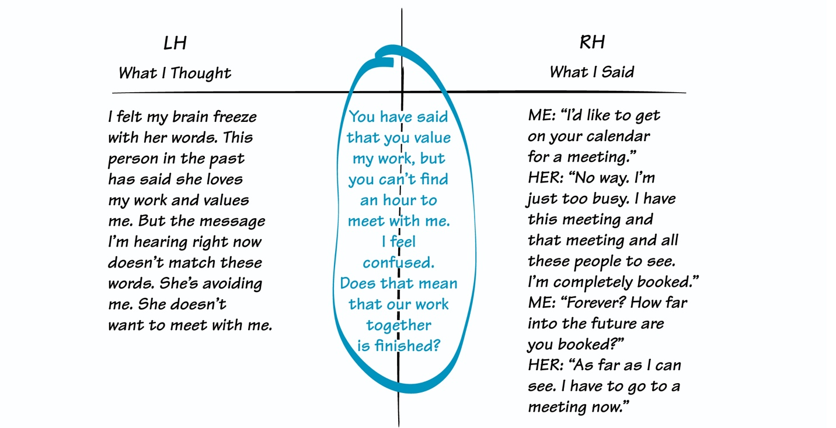
The “Eye of the Needle” integrates a communication strategy developed by management theorist Chris Argyris called the “left-hand/right-hand column” with the work of neuroscientist Candace Pert on emotional memory. By identifying the parts of a conversation that remain unspoken and the feelings that underlie those responses, we can better integrate our emotional and logical response so that we communicate completely, speaking the whole truth in a state of mutual respect.
Using Eye of the Needle as a tool enables us to integrate emotion and reason, eliminating the stress response and resulting in wisdom. Emotion is real. It cannot be ignored or overridden without a price, which is eventually illness. But giving full vent to emotion destroys relationships, which is also unacceptable. The power of truth comes through threading the needle—honoring emotion and reason as valuable human assets, honoring the other person, and honoring each of our unique needs and traits.

YOUR THOUGHTS
Please send your comments about any of the articles in THE SYSTEMS THINKER to editorial@pegasuscom.com. We will publish selected letters in a future issue. Your input is valuable!
Nancy Oelklaus (NancyOelklaus@gmail.com) coaches individuals to lead the lives they truly want. She also designs private retreats in Sedona, Arizona, where she resides. She is the author of 5 books available on Amazon.

